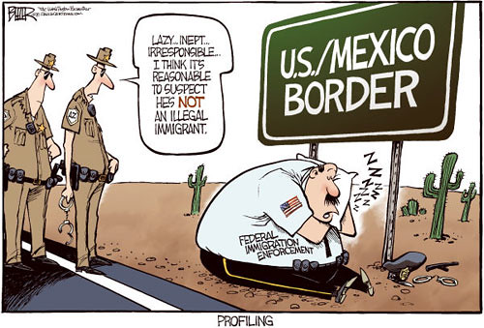
Helpful phrases

Describing something is easier if you know some phrases that you can use. Here is a list of some positive and negative aspects of immigration:

Reality/Positive aspects:
Immigrants …..
…could be skilled or unskilled labourers (workers).
…are needed in many areas e.g. agriculture, private households, childcare, nursing homes, etc.
…are willing to do jobs that nobody else wants to do.
…work hard to make a living/to make ends meet/earn their own money.
… are mostly honest, hardworking people.
…don’t commit more crimes than other groups of society.
…pay taxes, just like everyone else.
…boost the economy.
…are ambitious to create a successful life for themselves and their families.
…integrate quickly
…bring their cultures with and diversify (American) culture e.g. food, clothing, music, etc.
…try to adapt to American society
…are open to other cultures/accepting of change
…are willing to learn another language

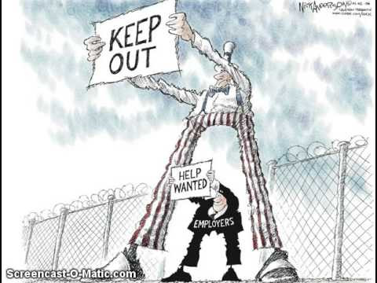
Prejudiced/Negative aspects:
Immigrants…
…take jobs away from American citizens
…are lazy and don’t want to work
…live off of welfare and cost American citizens money
…commit crimes
…live off of taxpayers’ money
…cause a strain on public services
…cause the neighbourhood to change
…will work for less money, so the wages for unskilled jobs is reduced
…could be terrorists
…make America lose its culture by bringing their own culture with them
…don’t want to learn the language

